**Introduction :**

Urban areas are facing an ever-growing problem of waste management due to increasing population and consumption. Traditional garbage collection methods are inefficient, leading to overflowing dustbins, unhygienic conditions, and high operational costs. To address this issue, we propose an AI-powered Smart Dustbin Management System that not only monitors fill levels and waste pickup but also predicts the number, type, and optimal placement of dustbins using machine learning based on collected data.

Our system aims to bring intelligence to waste collection by analysing real-time sensor data and historical trends to make smarter decisions. Instead of following fixed schedules, garbage trucks can be routed dynamically based on which bins are actually full. This not only helps reduce fuel consumption and labor hours but also ensures that streets remain cleaner and healthier. Additionally, by understanding patterns in how different areas generate waste, the system can suggest where more bins are needed, what size they should be, and how often they should be serviced. Over time, this leads to better resource allocation and a more sustainable urban waste management strategy.

By integrating AI with IoT-enabled dustbins, cities can move towards a cleaner, smarter, and more efficient waste management infrastructure.

**Problem Statement:**

In many cities today, garbage collection still relies on outdated methods that don’t keep up with the pace of urban growth and rising waste generation. Dustbins are often placed arbitrarily, without any analysis of how much waste is actually produced in specific areas. This results in some bins overflowing while others remain underused. Collection trucks follow fixed routes and schedules, regardless of whether bins are full or not, wasting time, fuel, and manpower.

Moreover, there’s little to no data being used to understand waste patterns or predict future requirements. This makes it difficult for municipal authorities to plan ahead or adapt to changes in population, consumption habits, or environmental goals. Without real-time insights or predictive tools, cities end up reacting to problems rather than preventing them.

There’s also no clear system to decide what type of bin (dry, wet, recyclable) is needed in a given area, leading to improper waste segregation and increased processing costs later. Overall, the lack of intelligent, data-driven waste management results in inefficiencies, higher operational costs, and negative impacts on public health and the environment.

This project addresses these challenges by proposing a smart system that uses real-time data and AI to improve how bins are placed, how waste is collected, and how cities plan for future needs.

**Objectives :**

**Primary Objectives :**

* Monitor garbage levels and generate alerts using LoRa and ESP modules.
* Collect data regarding location, pickup time, fill frequency, and material composition.
* Predict the number, location, and types of dustbins required using AI.

**Secondary Objectives :**

* Visualize the dustbin data in a web dashboard.
* Provide real-time insights to city waste managers.
* Optimize vehicle dispatch routes using data analytics.

**Methodology :**

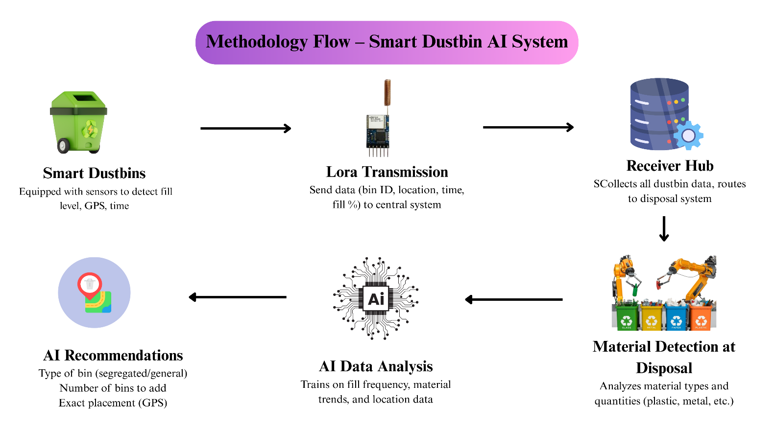

**Explanation**:

* **Step 1**: Each smart dustbin collects data: GPS location, fill time, and bin ID.
* **Step 2**: LoRa modules send data to a central receiver hub.
* **Step 3:** Receiver Hub Aggregates Data
* **Step 4**: Waste Material Detection at Disposal Station
* **Step 5**: Data Storage & Processing
* **Step 6**: AI-Based Analysis & Recommendation

**Tools and Techniques Used:**

**Tools :**

| **Tool/Hardware** | **Purpose** |
| --- | --- |
| ESP8266 / ESP32 | Data transmission |
| LoRa SX1278 | Long-range communication |
| Ultrasonic Sensor | Bin fill detection |
| Python | AI model and data processing |
| Flask | Backend web service |
| Pandas | Data manipulation |
| Matplotlib/Plotly | Data visualization |
| HTML/CSS/JS | Website frontend |
| SQLite/CSV | Lightweight database for testing |

**Techniques :**

1. **Supervised Learning for Bin Type Prediction**

Supervised machine learning algorithms are used to predict what type of dustbin (dry, wet, or recyclable) should be placed in a specific area. This is done by training the model on labelled data such as the type of waste generated in different zones, user behaviour, and past trends. For example, if a neighbourhood mostly generates food waste, the model can suggest placing more wet waste bins there. Algorithms like Decision Trees or Random Forests can be used to make these predictions accurately.

1. **K-Means Clustering for Finding Optimal Dustbin Locations**

K-Means is an unsupervised learning algorithm that helps group locations based on similar waste generation patterns. By applying this method to geographic data (like GPS coordinates of current bins and waste density), we can identify clusters where bins are overused or underused. This helps in deciding the most effective and balanced placement of new bins to ensure coverage and avoid overflow in high-demand areas.

1. **Time-Series Analysis for Bin Fill Frequency**

Time-series analysis helps understand how quickly bins fill up over time. By analysing patterns in bin fill data collected daily or hourly, we can predict peak waste generation times and days. This helps in planning timely pickups and avoiding overflow. Models like ARIMA or LSTM can be applied to forecast future bin fill levels based on historical trends.

1. **Geospatial Mapping using Latitude-Longitude Clusters**

Using GPS data, each dustbin's exact location is mapped, and clustering is done to visualize hotspots where bins are either frequently full or underused. This helps waste management teams see the bigger picture of bin distribution, optimize service coverage, and plan routes better. Geospatial mapping also aids in making data-driven decisions for installing new bins in underserved or high-traffic areas.

**Proposed Results:**

The outcome of this project will be a fully functional prototype capable of making intelligent recommendations and providing useful insights for city waste management. The expected results include:

* **Accurate Bin Quantity Recommendations:**  
  The system will suggest the optimal number of dustbins needed in a particular area based on waste generation data.
* **Bin Type Prediction:**  
  It will identify the appropriate type of bins (dry, wet, recyclable) required in each location, depending on the nature of the waste collected.
* **Optimal Bin Placement:**  
  Based on geospatial analysis and a 300-meter effective coverage per bin, the system will recommend ideal placement points across streets to ensure full coverage.
* **Interactive Data Visualization:**  
  A web dashboard will be developed to visually display real-time bin data, fill levels, collection history, and AI-driven recommendations in an intuitive format.
* **Operational Efficiency:**  
  By providing smarter routing and placement decisions, the system aims to reduce bin overflows, improve collection frequency, and make overall waste management more cost-effective and efficient.

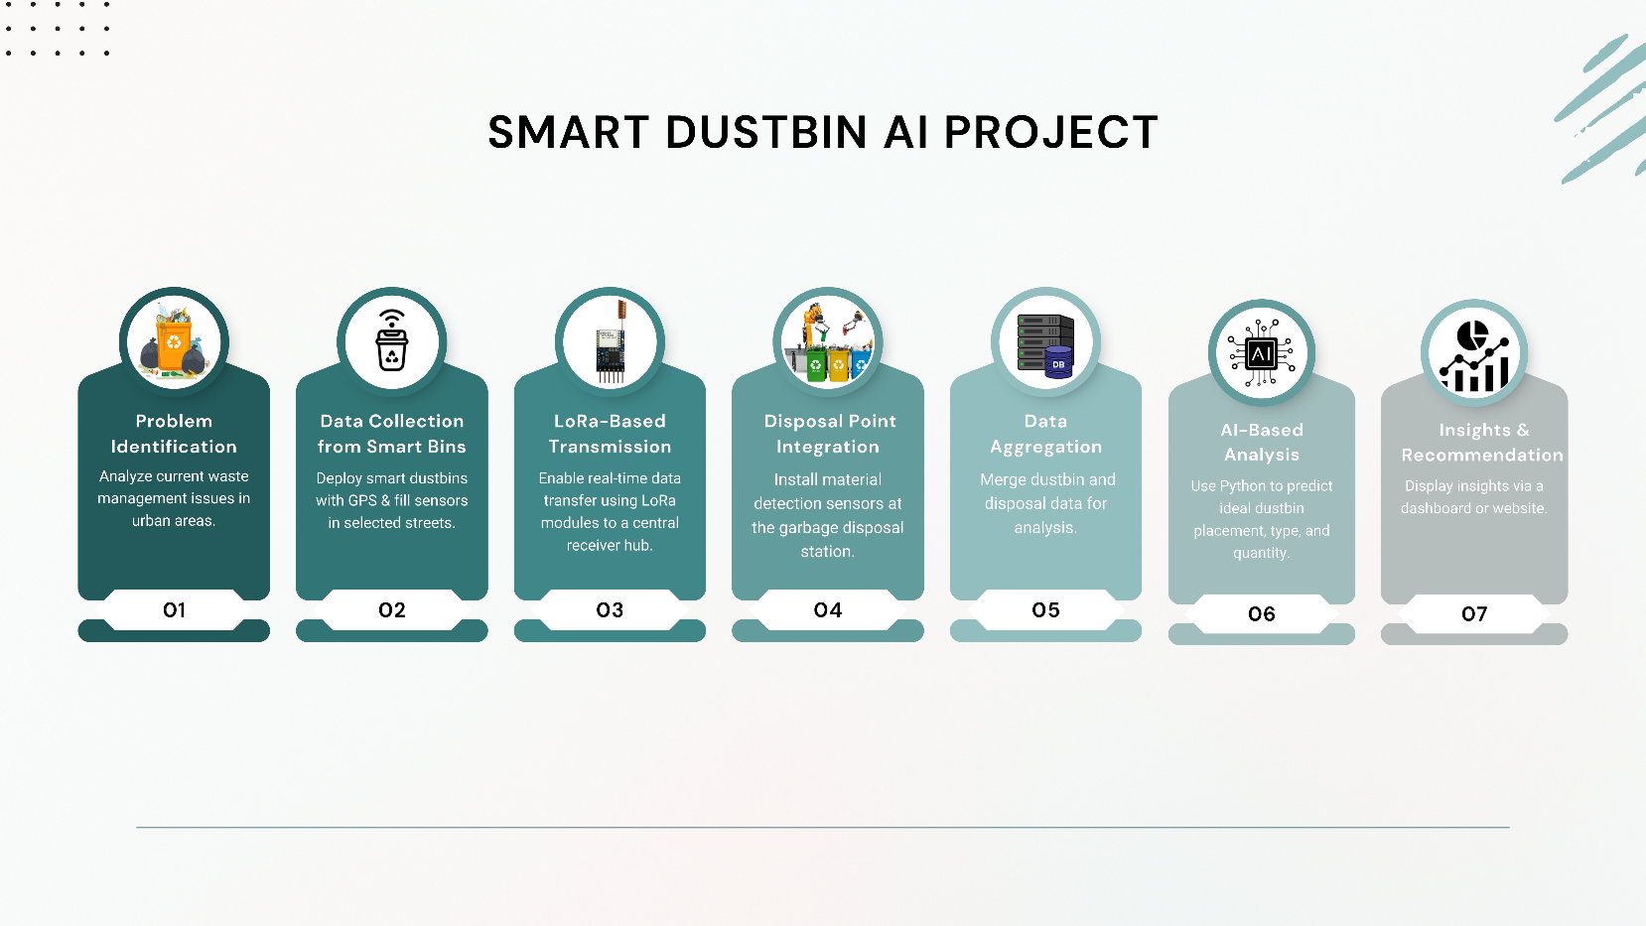**Road Map:**

**References :**

1. Smart waste management: A paradigm shift enabled by artificial intelligence  
   Summary : Discusses how AI can transform traditional waste management through smart decision-making.
2. IoT Based Smart Dustbin  
   Summary : Presents a design for dustbins equipped with IoT sensors to monitor fill levels in real-time.
3. Machine learning-based automated waste sorting in the construction industry  
   Summary : Applies machine learning to classify and sort construction waste more efficiently.
4. Sustainable Waste Management through ML-based Real-Time Trash Bin Prediction  
   Summary : Uses machine learning models to detect and predict waste levels for optimized collection.
5. Artificial intelligence for waste management in smart cities: a review  
   Summary : Provides a broad review of how AI technologies are being integrated into urban waste systems.
6. Smart Bin system with waste tracking and sorting mechanism using IoT  
   Summary : Proposes a smart bin that tracks waste disposal and performs automated sorting.
7. An Artificial Intelligence Based Predictive Approach for Smart Waste Management  
   Summary : Implements CNN models to estimate waste mass for better collection planning.
8. A survey of smart dustbin systems using the IoT and deep learning  
   Summary : Surveys recent developments combining IoT and deep learning in smart bin technologies.
9. Machine learning approach for a circular economy with waste recycling  
   Summary : Describes an ML framework to classify recyclable materials for promoting a circular economy.
10. Artificial Intelligence Smart Dustbin  
    Summary : Explores the design of a dustbin that uses AI for smart sensing and automated waste handling